CPE301 – SPRING 2019

MIDTERM 2

Student Name: Ivan Soto

Student #: 2000921825

Student Email: sotoi2@unlv.nevada.edu

Primary Github address: https://github.com/sotoi2/submission_da

Directory: submission_da/tree/master/ESD301/Midterm2/Midterm2

Submit the following for all Labs:

1. In the document, for each task submit the modified or included code (only) with highlights and justifications of the modifications. Also, include the comments.
2. Use the previously create a Github repository with a random name (no CPE/301, Lastname, Firstname). Place all labs under the root folder ESD301/Midterm, sub-folder named LABXX, with one document and one video link file for each lab, place modified asm/c files named as LabXX-TYY.asm/c.
3. If multiple asm/c files or other libraries are used, create a folder LabXX-TYY and place these files inside the folder.
4. The folder should have a) Word document (see template), b) source code file(s) and other include files, c) text file with youtube video links (see template).

1. **COMPONENTS LIST AND CONNECTION BLOCK DIAGRAM w/ PINS**

List of Components used

Block diagram with pins used in the Atmega328P

Mini USB Cable

Breadboard

Male

ESP8266

APDS9960

1. **INITIAL/MODIFIED/DEVELOPED CODE OF TASK 1/A**

Insert initial code here

/*

* Midterm2.c

*/

#include "SparkFun_APDS9960.h"

#include "i2c_master.h"

#include <util/delay.h>

#include <stdlib.h>

#include <stdint.h>

#include <avr/io.h>

#include <stdio.h>

#include <avr/interrupt.h>

#define *F_CPU* 16000000UL

#define BAUD 9600

#define FOSC 16000000

#define UBRREQ FOSC/16/BAUD -1

#define APDS9960_WRITE 0x72

#define APDS9960_READ 0x73

void UART_init (void);

void APDS_init (void);

int uart_placingchar( char c , *FILE* *stream);

*FILE* str_uart = *FDEV_SETUP_STREAM*(uart_placingchar, *NULL* , *_FDEV_SETUP_WRITE*);

void readvalue(void);

*uint16_t* red;

*uint16_t* green;

*uint16_t* blue;

int main( void )

{

UART_init(); // UART values

APDS_init(); // APDS9960

i2c_init(); // I2C

*stdout* = &str_uart;

red = 0;

green = 0;

blue = 0;

*_delay_ms*(5000); // for ap info

*printf*("AT+CWMODE=3\r\n");

*_delay_ms*(2000);// For AT comm

*printf*("AT\r\n");

*_delay_ms*(5000); // wifi connected

*printf*("AT+CWJAP=\"\",\"\"\r\n"); // wifi settings

while(1)

{

// cloud connection

*_delay_ms*(5000);

*printf*("AT+CIPSTART=\"TCP\",\"api.thingspeak.com\",80\r\n");

// Connection making

*_delay_ms*(5000);

*printf*("AT+CIPMUX=0\r\n");

*_delay_ms*(5000);

readvalue();

*printf*("AT+CIPSEND=104\r\n");

*printf*("GET https://api.thingspeak.com/update?api_key=KZR5N56BUMMM6Q7G&field1=0%05u&field2=%05u&field3=%05u\r\n", red, green, blue); // key

*_delay_ms*(3000);

}

}

void readvalue(){

*uint8_t* redH, redL;

*uint8_t* greenH, greenL;

*uint8_t* blueH, blueL;

// red

i2c_readReg(APDS9960_WRITE, APDS9960_RDATAH, &redH, 1);

i2c_readReg(APDS9960_WRITE, APDS9960_RDATAL, &redL, 1);

// green

i2c_readReg(APDS9960_WRITE, APDS9960_GDATAH, &greenH, 1);

i2c_readReg(APDS9960_WRITE, APDS9960_GDATAL, &greenL, 1);

// blue

i2c_readReg(APDS9960_WRITE, APDS9960_BDATAH, &blueH, 1);

i2c_readReg(APDS9960_WRITE, APDS9960_BDATAL, &blueL, 1);

red = (redH << 8) | redL;

green = (greenH << 8) | greenL;

blue = (blueH << 8) | blueL;

// limit

if (red > 255)

red = 255;

if (green > 255)

green = 255;

if (blue > 255)

blue = 255;

}

void APDS_init(void){

*uint8_t* setup;

i2c_readReg(APDS9960_WRITE, APDS9960_ID, &setup,1);

if(setup != APDS9960_ID_1) while(1);

setup = 1 << 1 | 1<<0 | 1<<3 | 1<<4;

i2c_writeReg(APDS9960_WRITE, APDS9960_POFFSET_DL, &setup, 1);

setup = DEFAULT_CONFIG1;

i2c_writeReg(APDS9960_WRITE, APDS9960_PPULSE, &setup, 1);

setup = DEFAULT_POFFSET_UR;

i2c_writeReg(APDS9960_WRITE, APDS9960_POFFSET_UR, &setup, 1);

setup = DEFAULT_POFFSET_DL;

i2c_writeReg(APDS9960_WRITE, APDS9960_ENABLE, &setup, 1);

setup = DEFAULT_ATIME;

i2c_writeReg(APDS9960_WRITE, APDS9960_CONFIG1, &setup, 1);

setup = DEFAULT_PERS;

i2c_writeReg(APDS9960_WRITE, APDS9960_PERS, &setup, 1);

setup = DEFAULT_CONFIG2;

i2c_writeReg(APDS9960_WRITE, APDS9960_CONFIG2, &setup, 1);

setup = DEFAULT_CONFIG3;

i2c_writeReg(APDS9960_WRITE, APDS9960_CONFIG3, &setup, 1);

i2c_writeReg(APDS9960_WRITE, APDS9960_ATIME, &setup, 1);

setup = DEFAULT_WTIME;

i2c_writeReg(APDS9960_WRITE, APDS9960_WTIME, &setup, 1);

setup = DEFAULT_PROX_PPULSE;

}

void USART_placingstring(char *StringPtr)

{

while ((*StringPtr != '\0')){ //poll for string inputs

while (!(UCSR0A & (1 << UDRE0))); // continue polling

UDR0 = *StringPtr; // UDR0 register taking a value

StringPtr++; // receiving characters

}

}

void UART_init(void)

{

//baud rate

*uint16_t* baud_rate = UBRREQ;

UBRR0H = baud_rate >> 8;

UBRR0L = baud_rate & 0xFF;

// use a stop bit

UCSR0C = (3 <<UCSZ00);

//receiver, transmitter enable

UCSR0B = ( 1 <<RXEN0)|( 1 <<TXEN0);

}

int uart_placingchar(char c, *FILE* *stream)

{

//poll until empty buffer

while ( !( UCSR0A & ( 1 <<UDRE0)) );

//storing data to buffer

UDR0 = c;

return 0;

}

1. **DEVELOPED MODIFIED CODE OF TASK 2/A from TASK 1/A**

Insert only the modified sections here

1. **SCHEMATICS**

Use fritzing.org

1. **SCREENSHOTS OF EACH TASK OUTPUT (ATMEL STUDIO OUTPUT)**

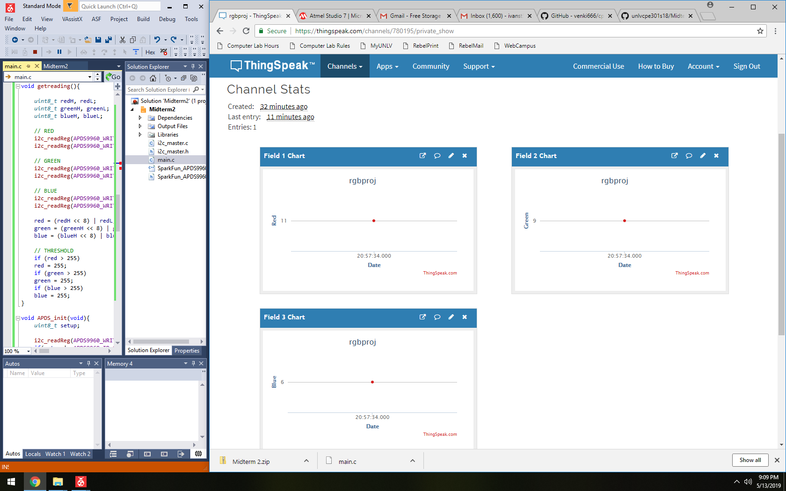

1. **SCREENSHOT OF EACH DEMO (BOARD SETUP)**

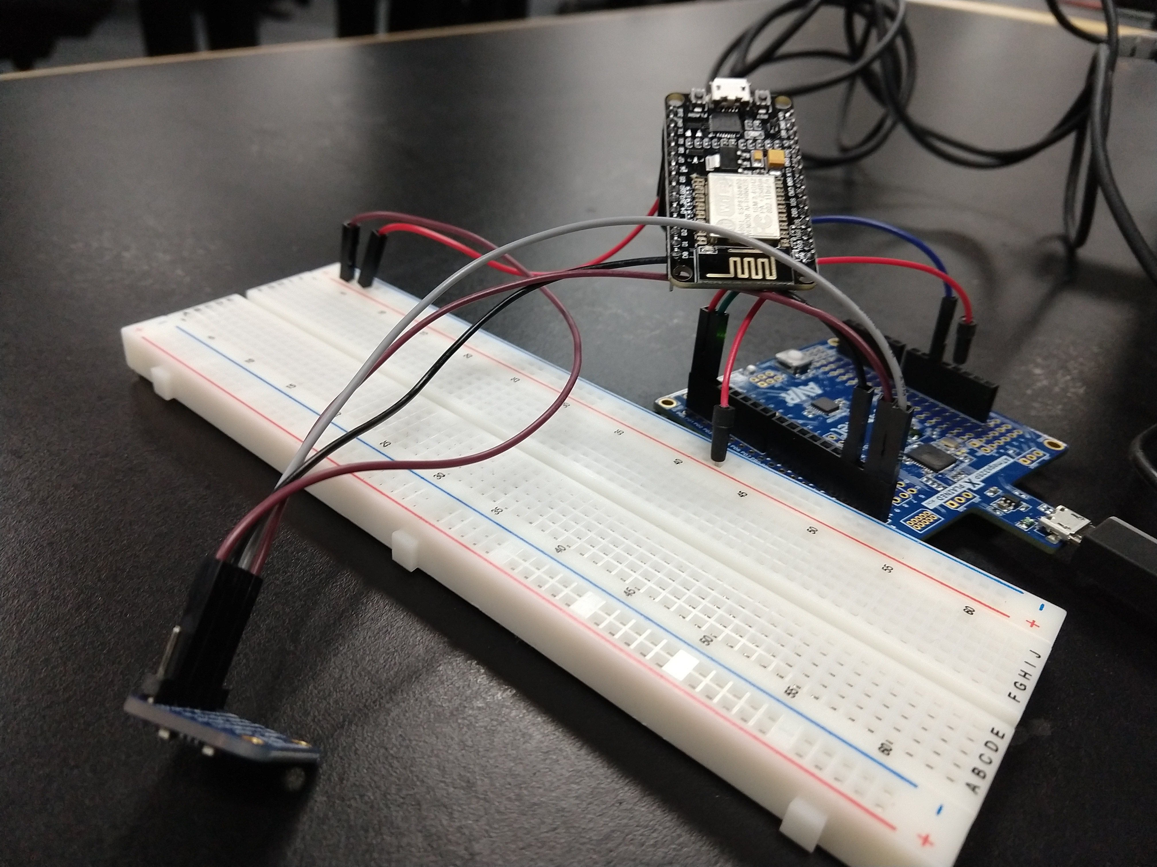

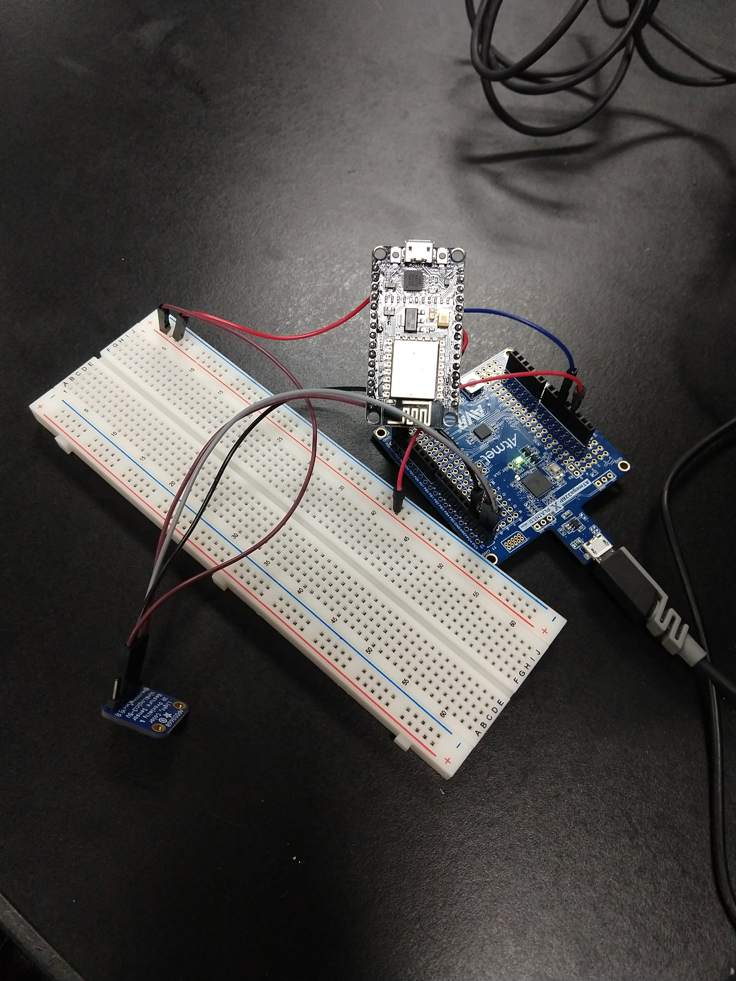

1. **VIDEO LINKS OF EACH DEMO**

<https://youtu.be/NfKgJHrxCuM>

1. **GITHUB LINK OF THIS DA**

https://github.com/sotoi2/submission_da/tree/master/ESD301/Midterm2/Midterm2

**Student Academic Misconduct Policy**

<http://studentconduct.unlv.edu/misconduct/policy.html>

“This assignment submission is my own, original work”.

Ivan Soto